UNIVERSITY OF TECHNOLOGY, JAMAICA
SCHOOL OF COMPUTING & INFORMATION TECHNOLOGY (SCIT)
ENTERPRISE SECURITY
Lab 1

Footprinting, Reconnaissance, and Scanning
Exercises
Performing Passive Reconnaissance
The best way to learn passive information gathering is to use the tools. In this exercise, you perform reconnaissance on several organizations. Acquire only the information requested.
Estimated Time: 20 minutes.
- Step 1. Review Table 3-10 to determine the target of your passive information gathering.
Table 1 Passive Information Gathering
Domain Name | IP Address | Location | Contact Person | Address and Phone Number
h4cker.org | 185.199.108.153 | California | Omar Santos | 88 Colin P. Kelly Jr. Street 94107 San Francisco UNITED STATES +1 415 735 4488
Examcram.com | 168.146.67.181 | Iowa | Pearson Data Center Network Engineers | 2510 N. Dodge St Iowa City IA 52245 United States +1-319-341-5597
Rackspace Technology | 72.3.246.59 | TX | Hansell Chris | 19122 US Highway 281N Ste 128  San Antonio, TX 78258-7667  United States
Rutgers.edu | 128.6.46.88 | NJ | William F Tate | 57 US Highway 1  New Brunswick, NJ 08901-8554  +18484457541
secretcorp.org |  |  | Omar Santos
- Step 2. Start by resolving the IP address. You can do this by pinging the site.
- Step 3. Next, use a tool such as https://www.whois.net or any of the other tools inclusive of the following:
  - http://www.betterwhois.com
  - https://whois.domaintools.com/
  - https://lookup.ickali ann.org
  - https://talosintelligence.com/reputation_center
- Step 4. To verify the location of the organization by using https://ipinfo.io or https://www.maxmind.com/en/geoip-web-services-demo
- Step 5. Use the ARIN, RIPE, and IANA to fill in any information you have yet to acquire.
- Step 6. Analyze the results.
Performing Active Reconnaissance
The best way to learn active information gathering is to use the tools. In this exercise, you perform reconnaissance on your own internal network. If you are not on a test network, make sure that you have permission before scanning it, or your action may be seen as the precursor of an attack.
Estimated Time: 15 minutes.
- Step 1. Run nmap -h from the terminal to see the various options in Kali.
- Step 2. You’ll notice that Nmap has many options. Review and find the option for a full connect scan. Enter your result here:__-A__
- Step 3. Review and find the option for a stealth scan. Enter your result here: _-sS__
- Step 4. Review and find the option for a UDP scan. Enter your result here: _-sU__

- Step 5. Review and find the option for a fingerprint scan. Enter your result here: _-O__
- Step 6. Perform a full connect scan on the windows 10 virtual machine. The syntax is nmap -sT IP_Address.
- Step 7. Perform a stealth scan on one of the local devices you have identified on your network. The syntax is nmap -sS IP_Address.
- Step 8. Perform a UDP scan on one of the local devices you have identified on your network. The syntax is nmap -sU IP_Address.
- Step 9. Perform a fingerprint scan on one of the local devices you have identified on your network. The syntax is nmap -O IP_Address.
Step 10. Observe the results of each scan. Could Nmap successfully identify the system? Were the ports it identified correct?. Here’s a short, ready-to-submit version:
Answer:
Nmap was able to correctly identify the open ports on the host (135/tcp – msrpc and 445/tcp – microsoft-ds), which are consistent with a Windows system. However, it did not successfully determine the exact operating system because the scan lacked both an open and a closed port, making the OS fingerprinting results unreliable.

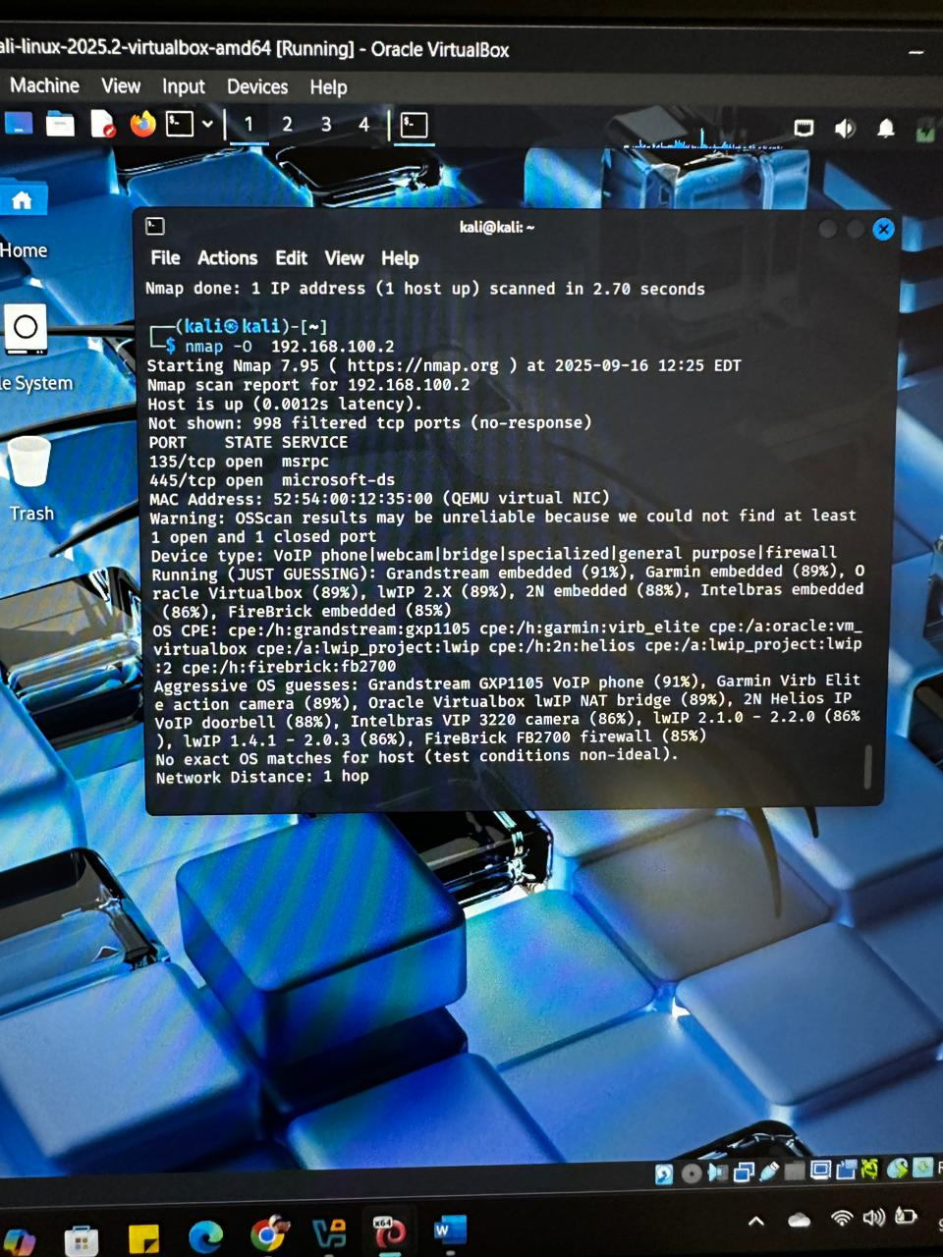1
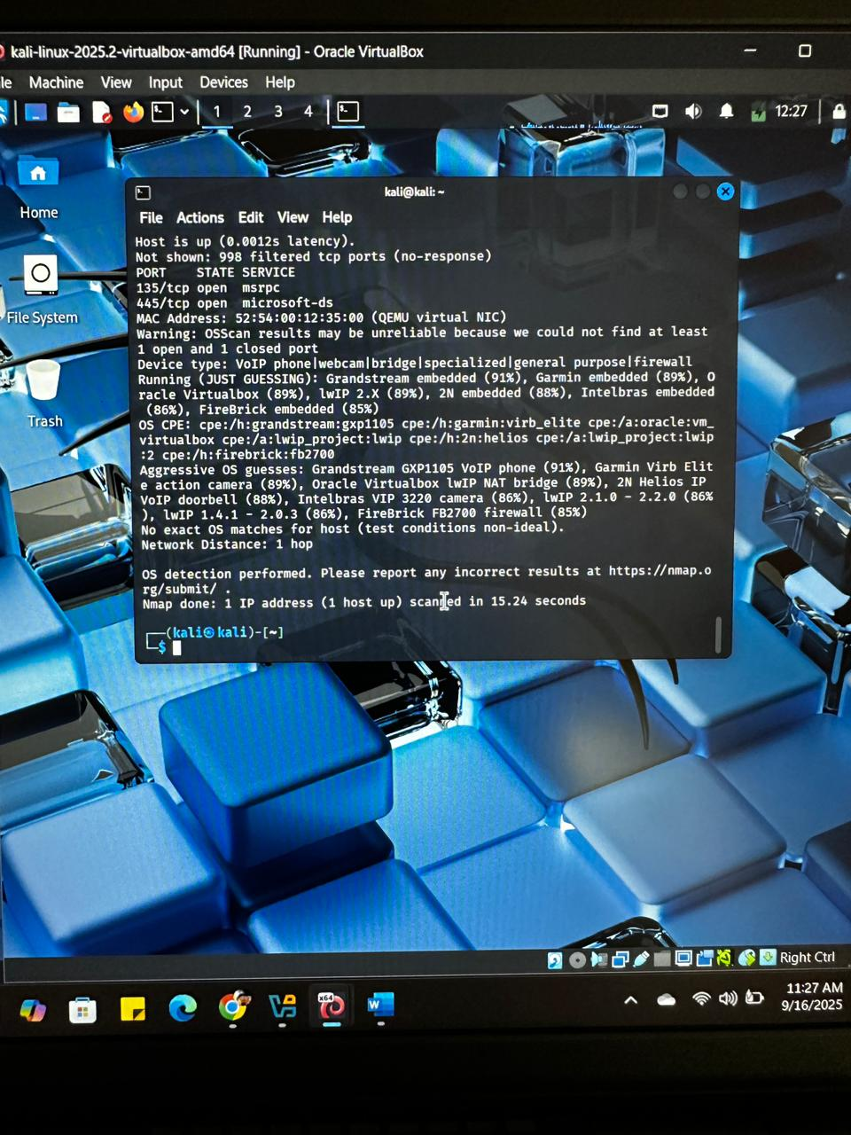

Performing Active Reconnaissance using Google Hacking Database (Google Dorking)
Google Dorking refers to using specific search operators and techniques to uncover hidden information that is not immediately visible on websites but is indexed by search engines like Google.
Google Hacking Database (GHDB): A curated list of search queries, known as "dorks," that can help discover sensitive information, including:
- Exposed passwords
- Vulnerable files
- Admin portals
- Email lists
Use Cases:
- Finding login pages.
- Exposing directories or sensitive data.
- Identifying misconfigurations.
Understanding Google Search Operators
Here are the most common Google search operators used in dorking:
- site: Limits results to a specific website or domain.
  - Example: site:example.com

- intitle: Searches for keywords in the title of a page.
  - Example: intitle:"index of"

- filetype: — Finds specific file types (e.g., PDFs, docs).
  - Example: filetype:pdf

- inurl: Finds URLs that contain certain words or patterns.
- Example: inurl:admin

- “” (quotes) — Finds exact matches for phrases.
  - Example: "password"

- - (minus) — Excludes specific words or domains from search results.
  - Example: site:example.com -www
Examples:
- Finding Exposed Login Pages: inurl:login site:edu
- Locating Exposed Documents: filetype:pdf confidential site:.com
- Discovering Exposed Admin Portals: intitle:"admin panel" inurl:admin

Visit the following website https://www.exploit-db.com/google-hacking-database
Answer the following:
- Find an excel file on the internet that contains usernames and passwords
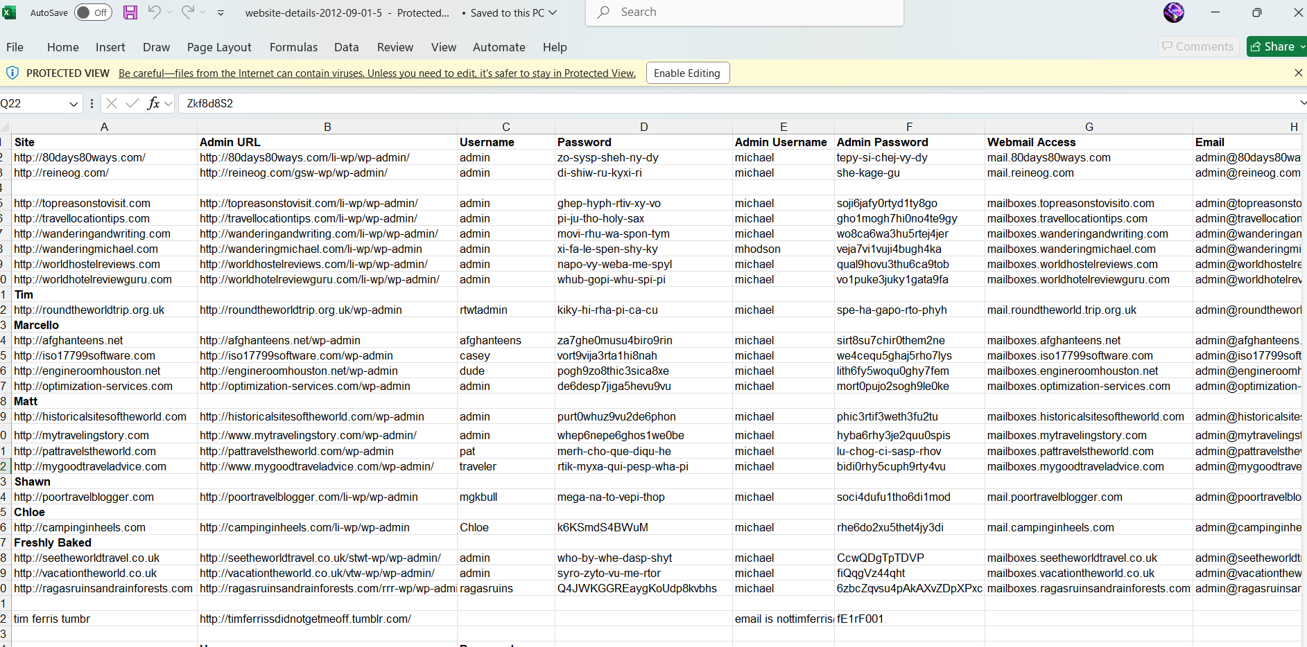

- Ethical Hacking video in a google drive

- IP Cameras with dvr
- Exposed Email Lists
- Exposed Directories
- Exposed Database Files
Harvester
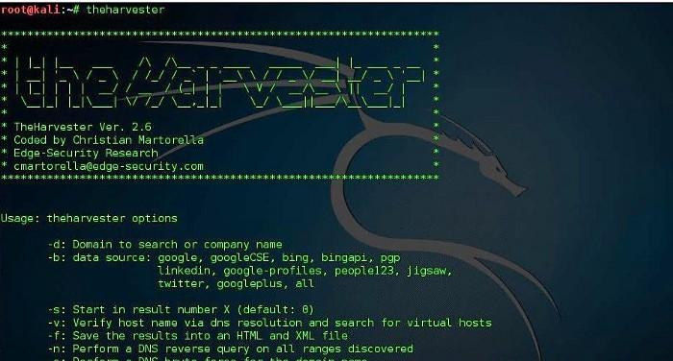
∙ Perform website footprinting
- Gather information about a target website using ping command line utility
- Gather information about a target website using Website Informer
- Extract a company’s data using Web Data Extractor
- Mirror the target website using HTTrack Web Site Copier
- Gather a wordlist from the target website using CeWL

